Final Project Design Phase
Computer Science - Week 11
Oct 3, 2026 - Version 0.0.4

For complete instructions and project ideas, refer to the assignment in Canvas. Specifically, review the final project requirements before you continue below. If you have not reviewed the project requirements in Canvas (you might have to go to the modules view and check the current or past week's content), you will not be able to properly complete the parts below. In addition, it may be helpful to review the information on this Drafter documentation page.

0) Project Planning and Preparation
Successful programmers spend time planning before they begin coding. After reviewing the project requirements, answer the following questions to help guide your design and development process.
- What concepts from class or previous assignments might help you complete this project? Which programming concepts (loops, conditionals, lists, classes, etc.) do you expect to use? What programming skills do you want to improve while completing this project?
Abstraction might help with this project. I am expecting to use loops, conditionals, lists, and classes….basically whatever is in the project specification page. I want to improve my debugging skills. I think this is the only skill that I can improve because AI is making the website so I can just test and fix.

- Which parts of the project do you expect to be the easiest for you? The hardest? Why?
The easiest part of the project is to actually make the code because AI is doing that. The hardest part is to debug the code because there is a high chance that artificial intelligence is going to miss this up.

- Even though you have not yet designed the final project, estimate which tasks will likely require the most time and effort? Which features or components should be implemented first?
Designing the project itself will probably require the most time and effort (I know this because I accidentally started doing the mockup instead of doing these questions). Components that should be implemented first are the dataclasses and the non-route functions that are heavily used by route functions.

- What distractions might interfere with your work and how will you minimize them? What resources will you need available while working? What questions, if any, do you still have about the assignment requirements?
No distractions will interfere with my work. While I am working, I don’t need any resources. No questions.

1) Site Diagram
Create a mock-up of your planned website. We suggest you make the mockup on paper, although you can also use software like PowerPoint or Slides to make a mockup. There is other design software that could also be used, but we strongly encourage you to keep it simple. Do not spend more than 15-30 minutes detailing the mock-up. Your goal should be to make a very quick and dirty diagram, to show that you have some kind of idea.

We recommend drawing each page as a rectangle, and laying out the text, buttons, and other components inside. Then, use arrows to indicate links between pages. Label each page the way you will name each function, and then put labels on the arrows to indicate what the button links. Also write down any parameters that should come into the pages.

In addition to the pages and routes, write down what fields your `State` will have, both their names and types. Think clearly about what data will need to be persistent across the entire website.

Add photo(s) or screenshot(s) of your website mock-up and labeled diagram on the next page.

I asked one of the TAs if this is allowed and he said that it was fine to take a screenshot of the pages of my to-be website and so I concluded that it was okay to screenshot the other things too….⬇️

Here is the navigation diagram and the route functions:
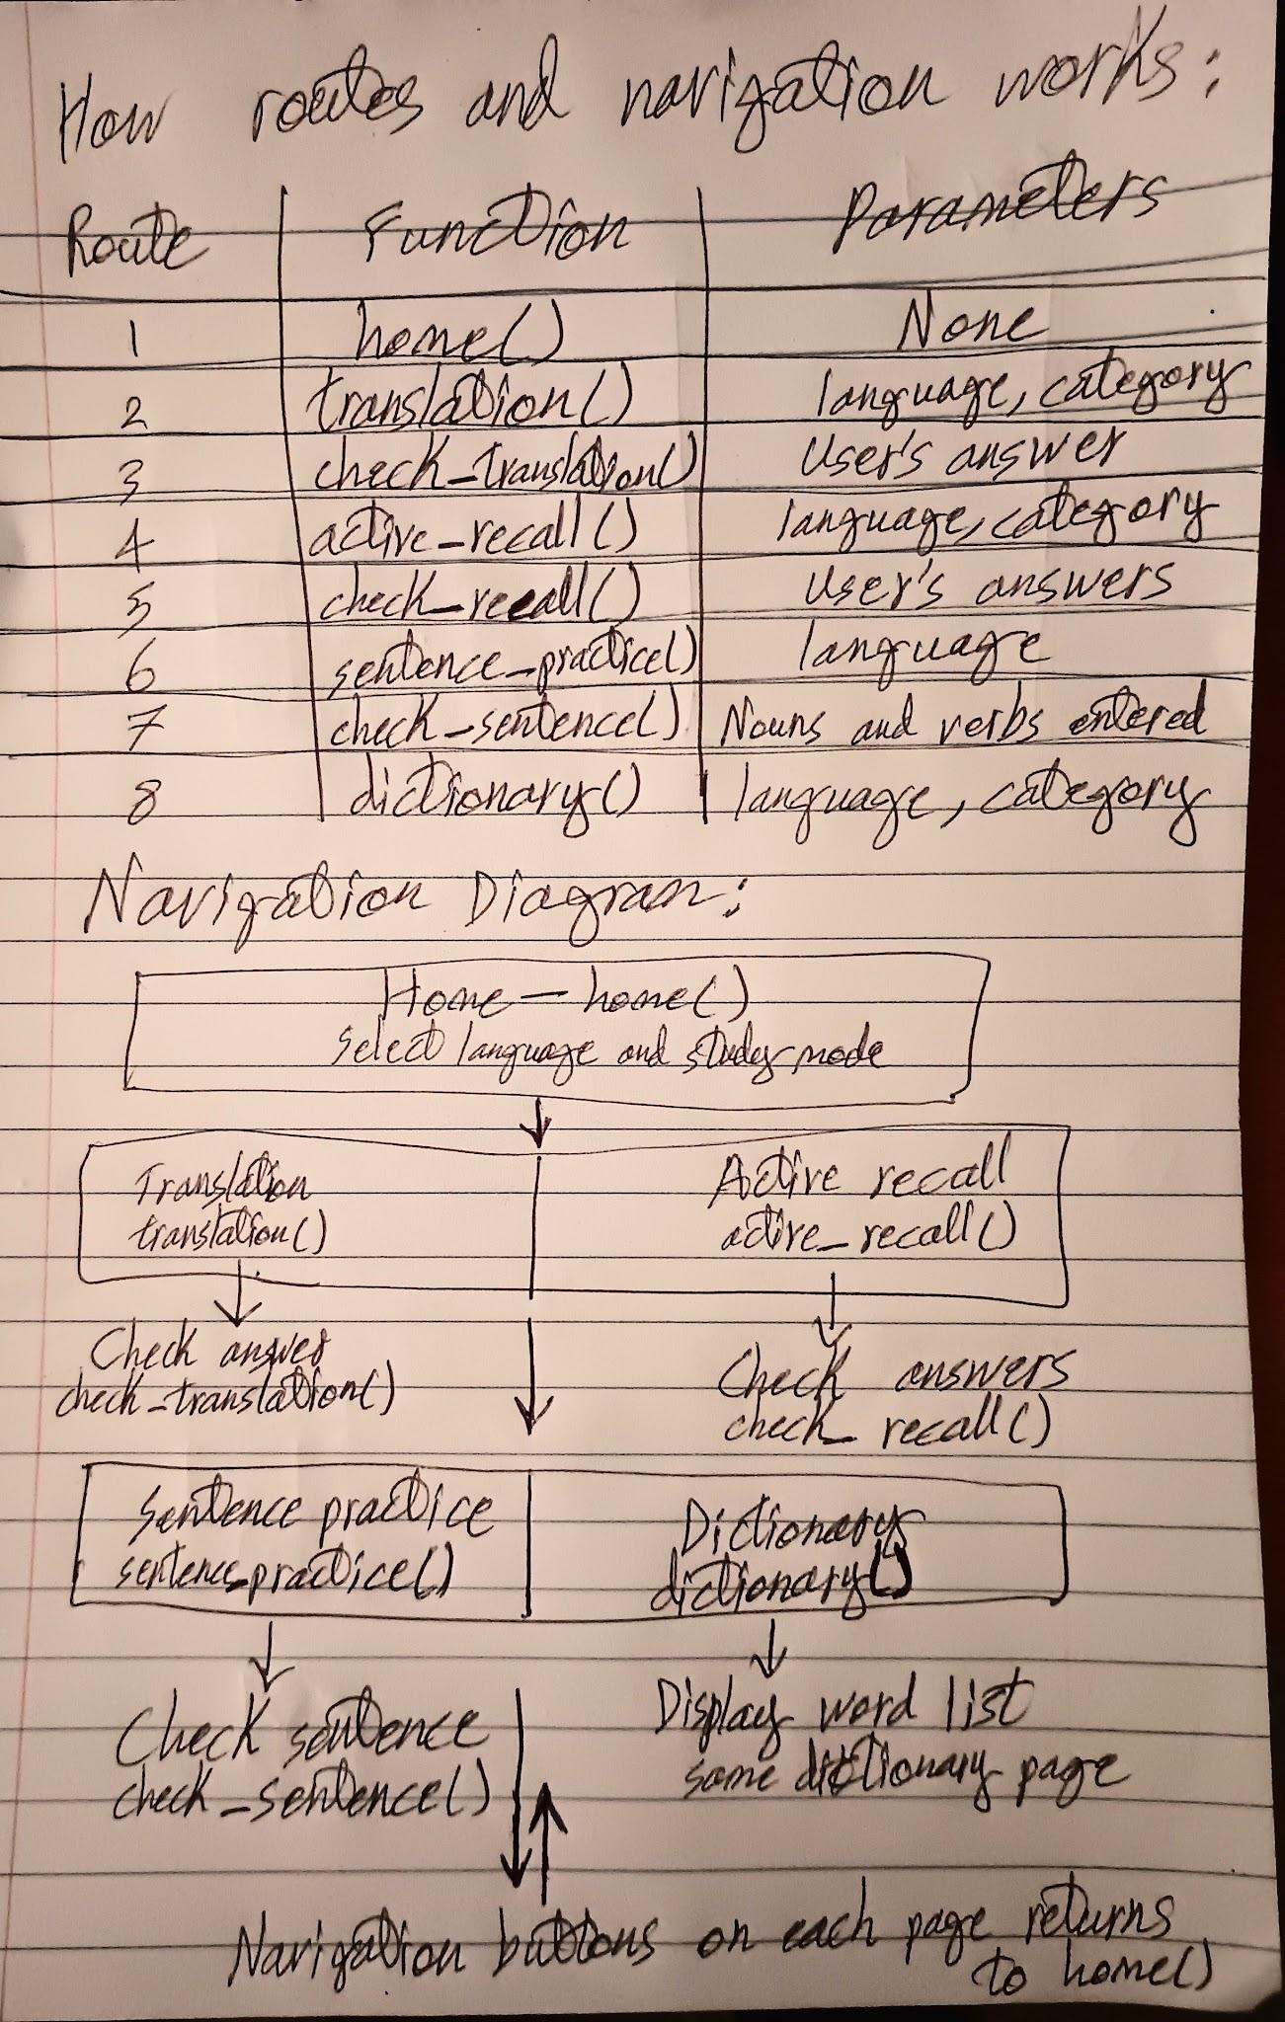
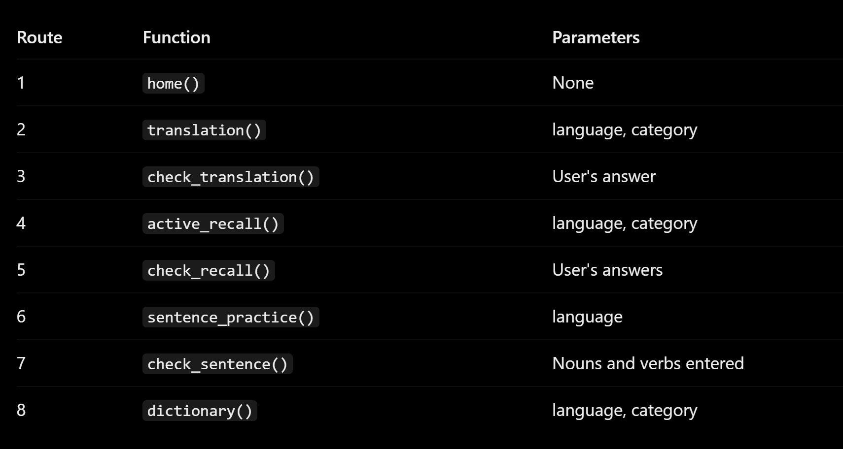

Here are the pages starting from page 1 and ending with page 5 (the display screen was small when I screenshotted these images, some of the pages were captured in two screenshots instead of one):
Page 1: (Main)
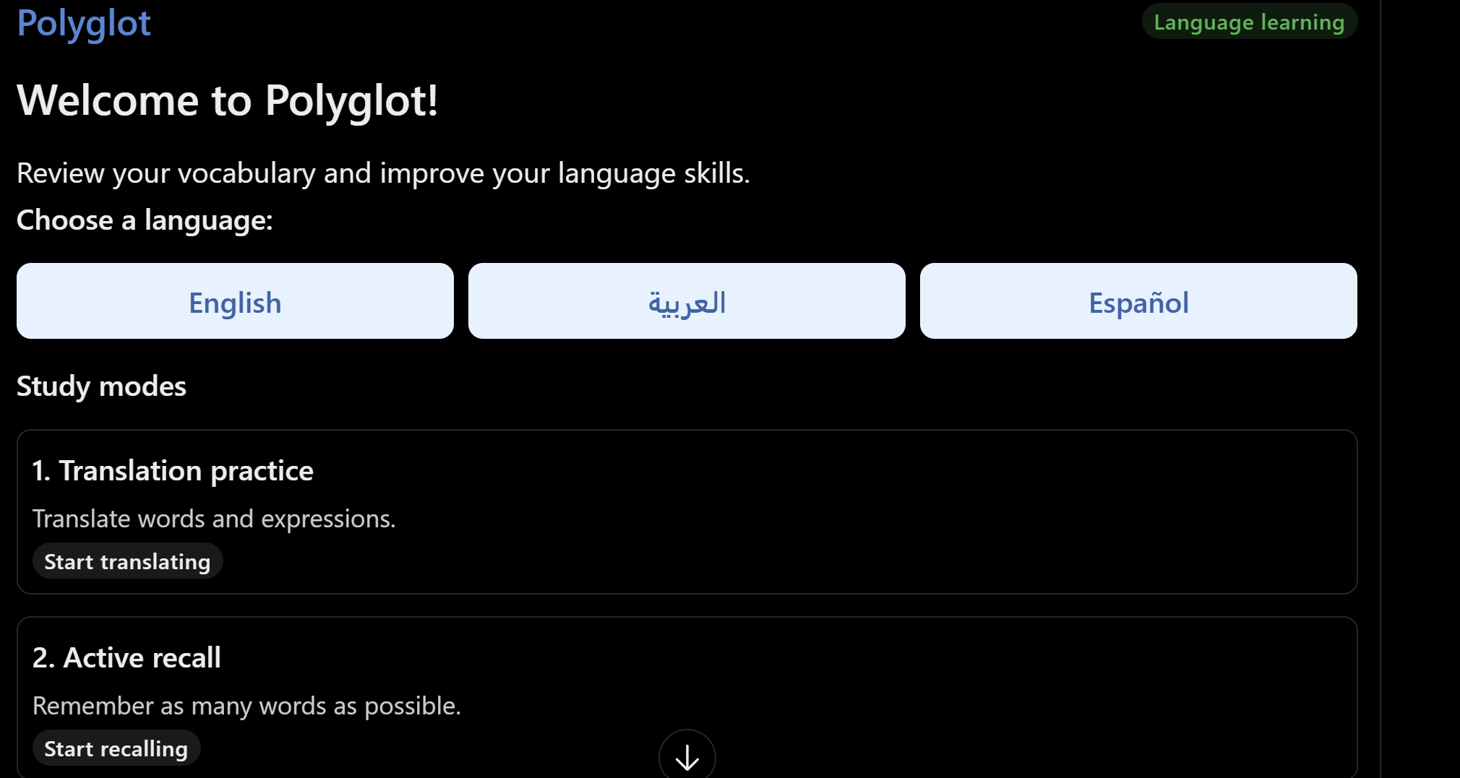
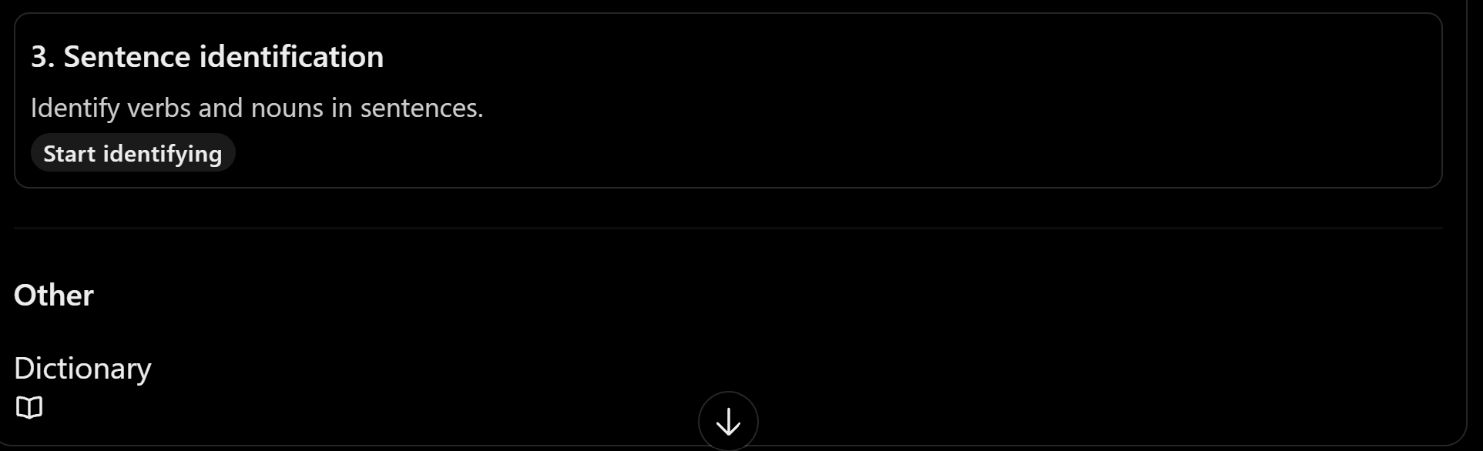

Page 2:
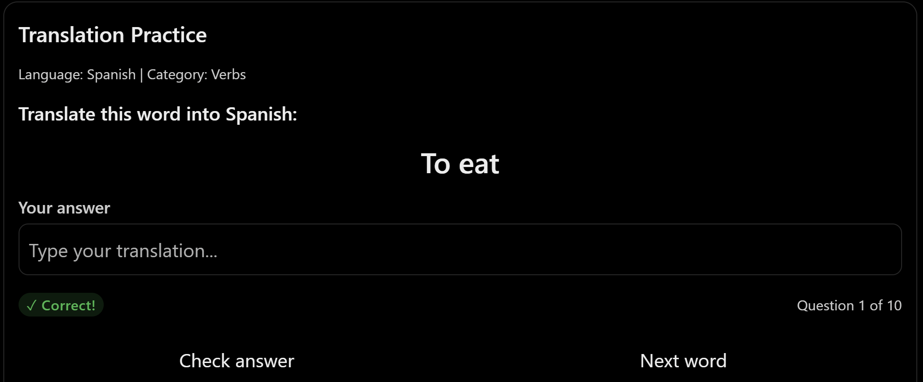

Page 3:
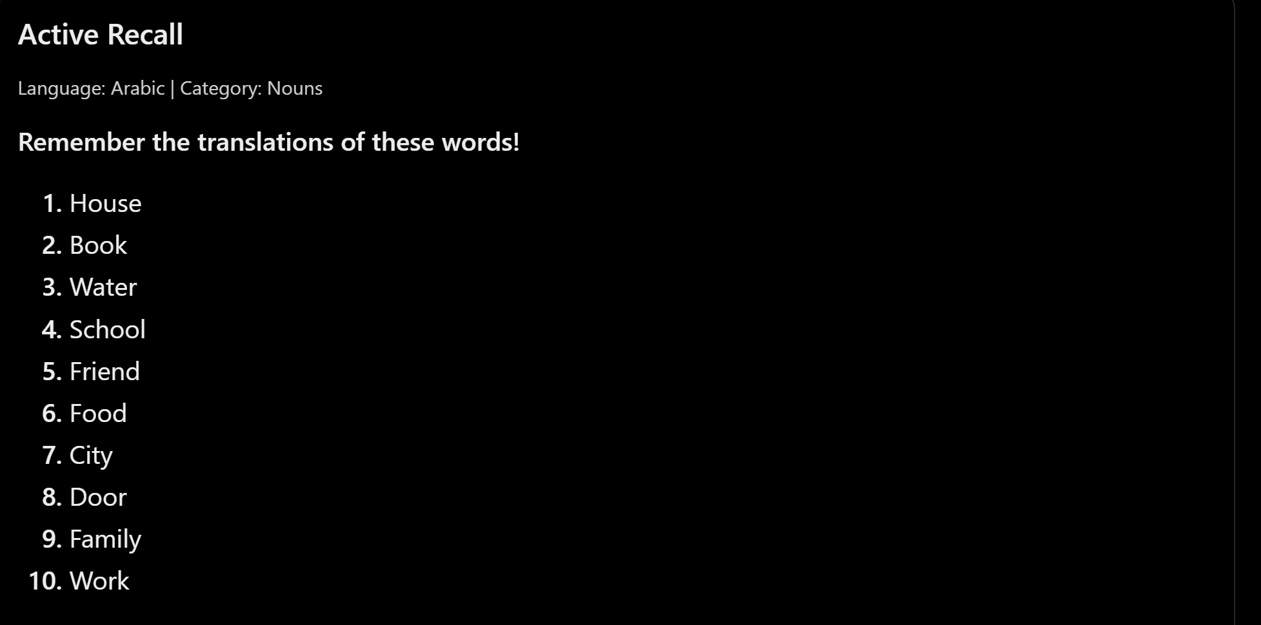
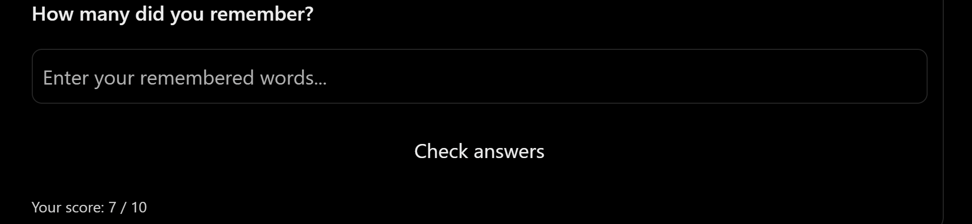

Page 4:
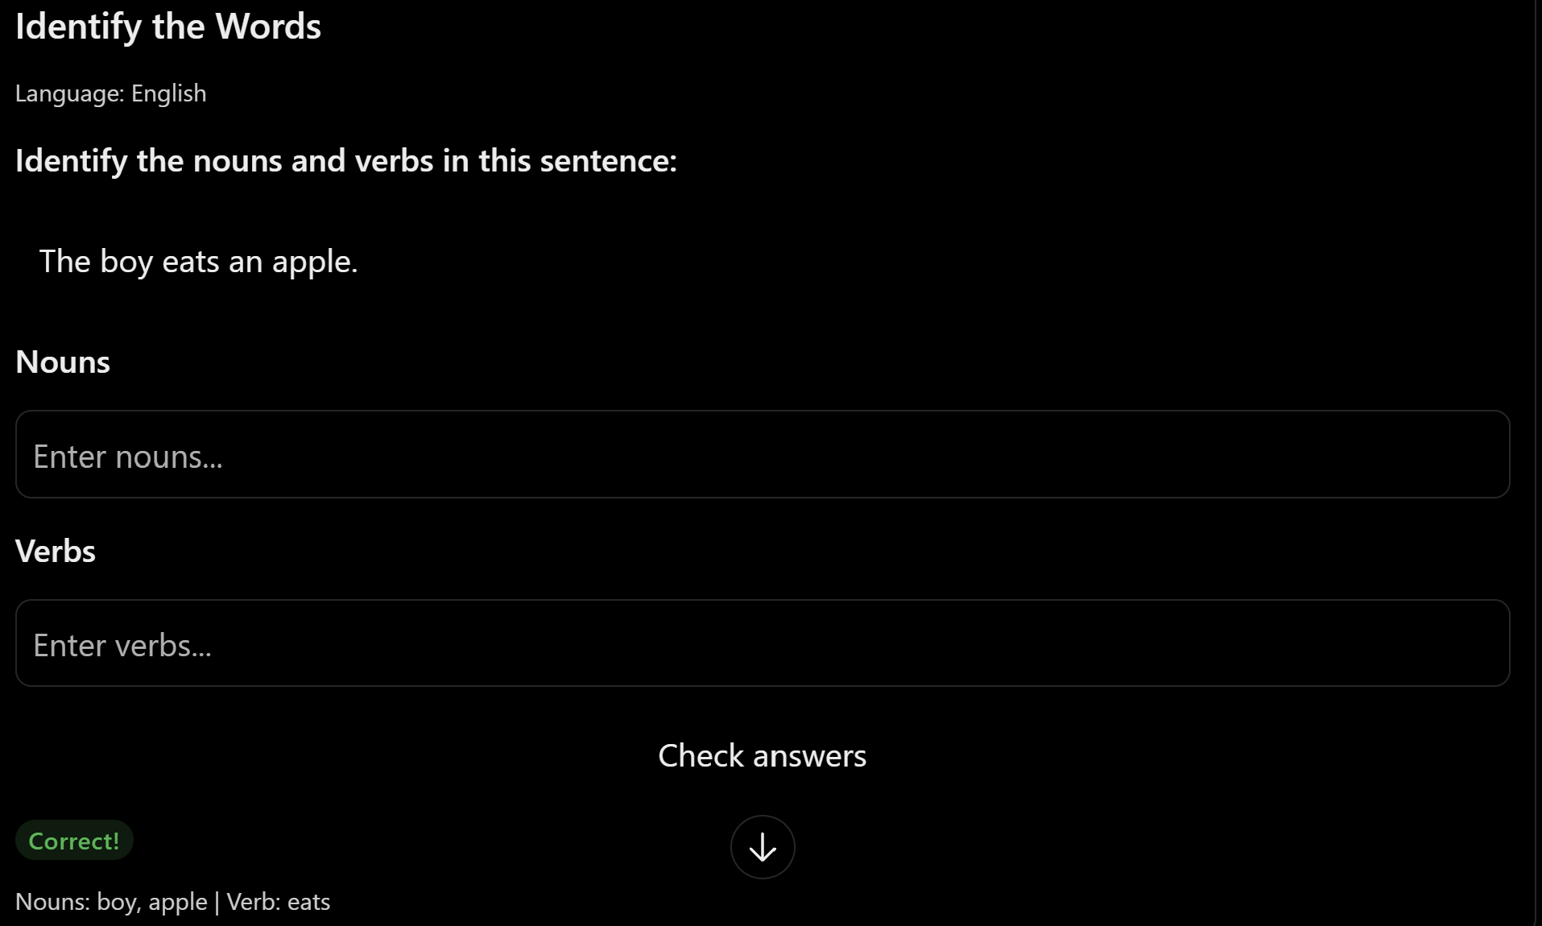

Page 5:
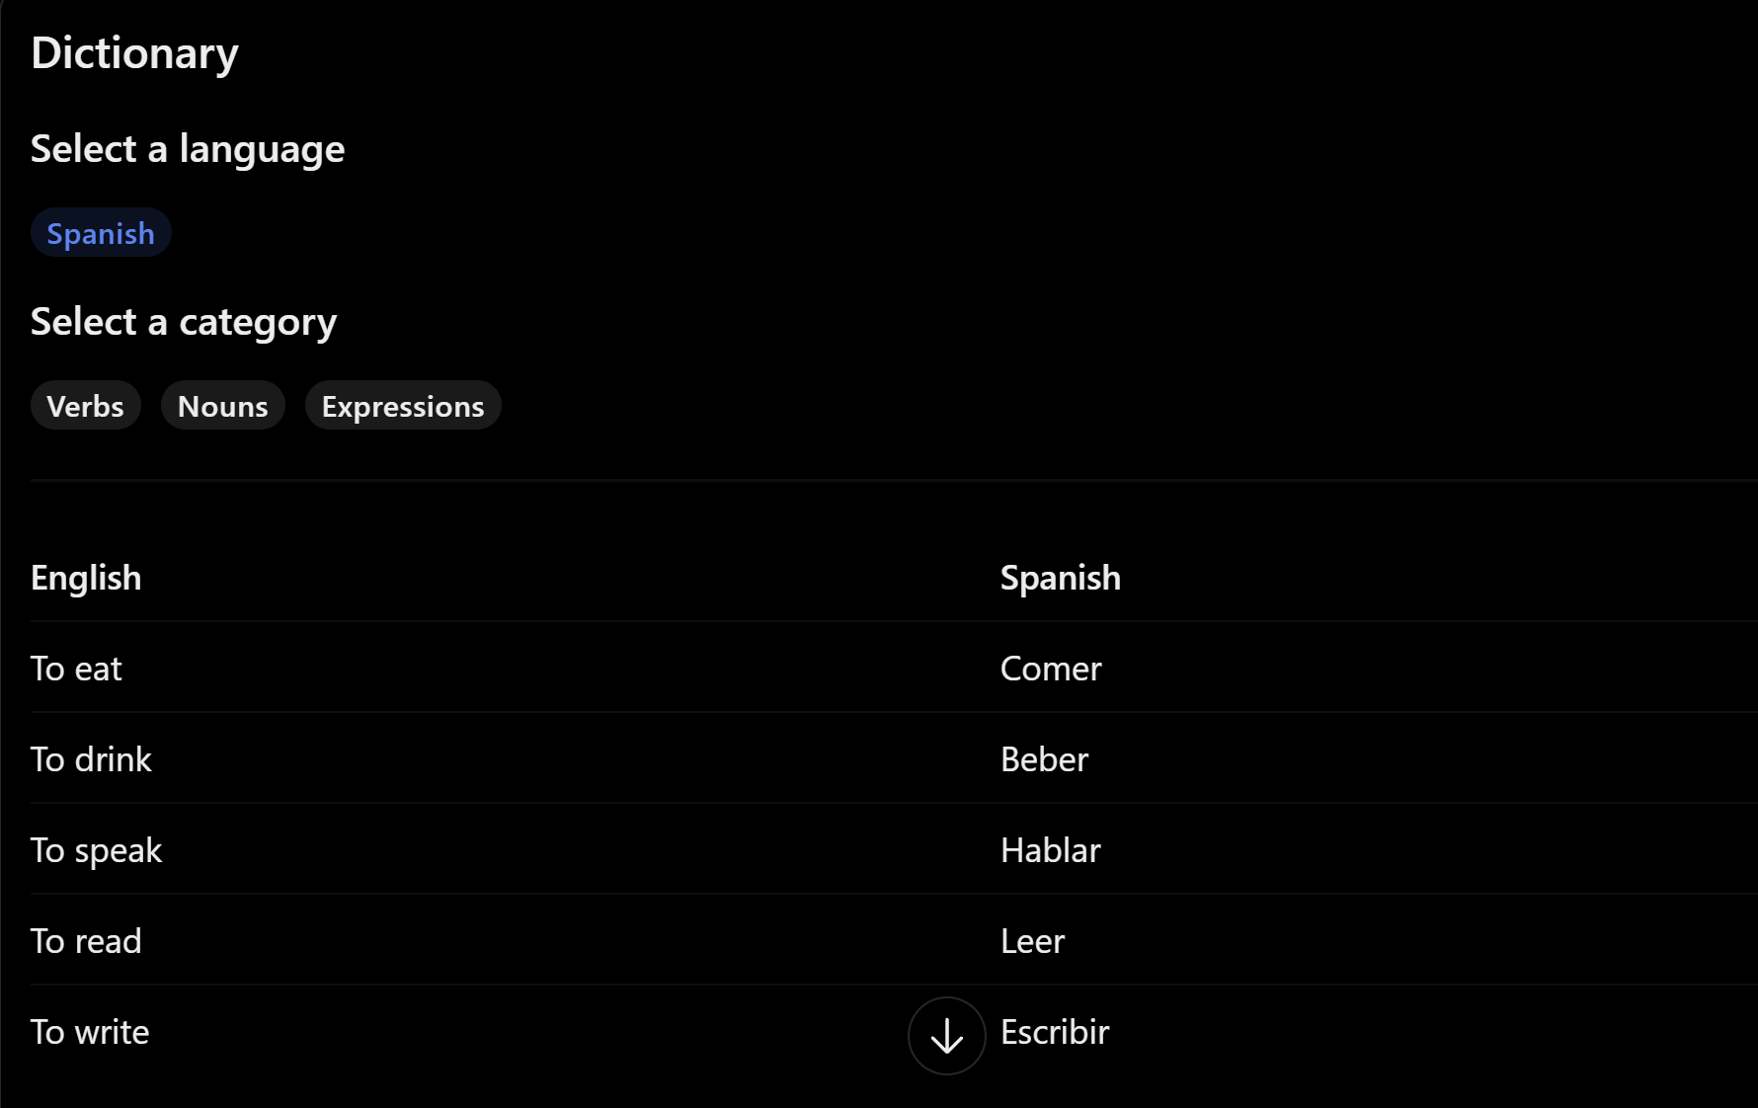

Here are the dataclasses:
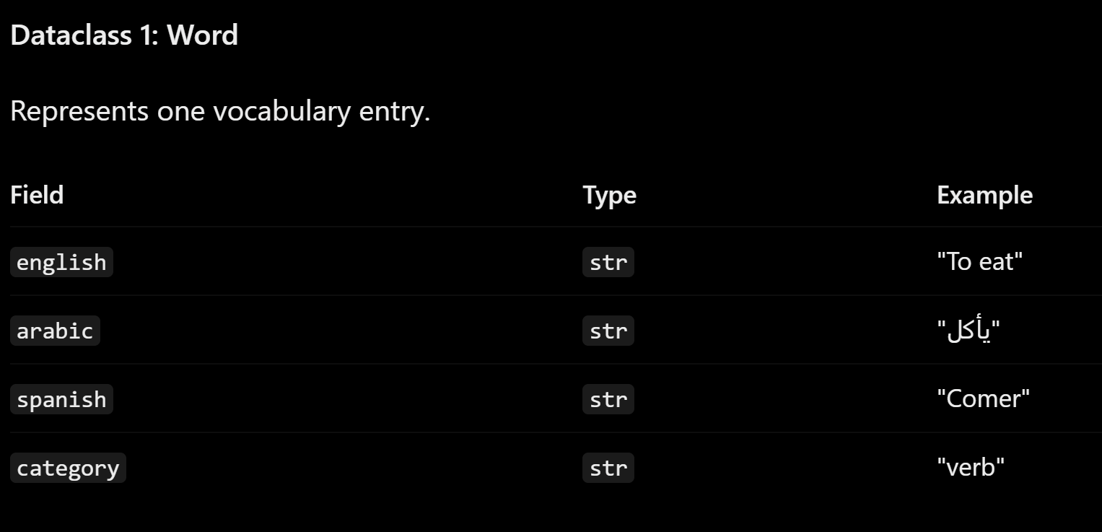
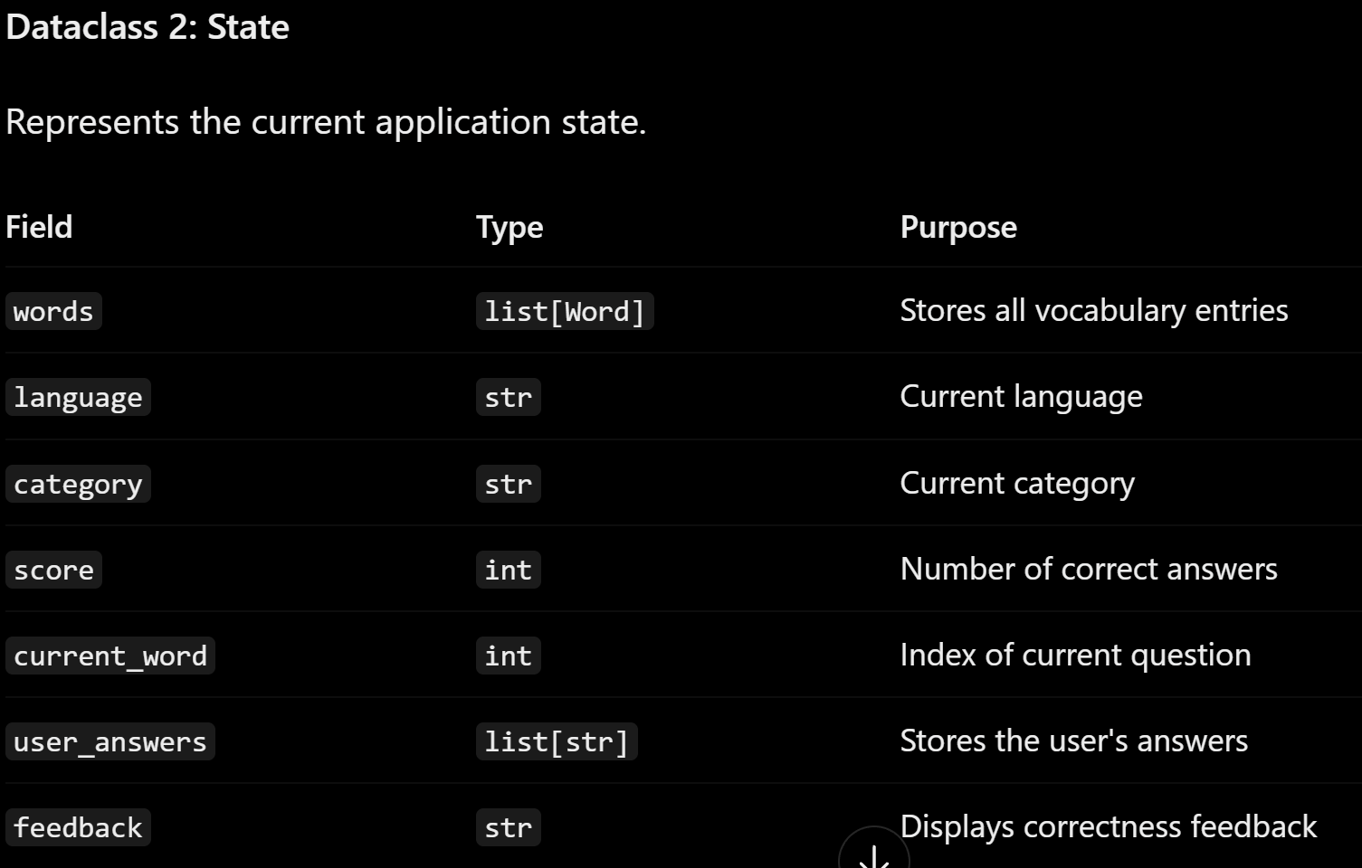

2) Implementing Requirements
This table should serve as a draft for how you will implement the requirements into your final project. You may change your ideas later on, but your final site must fulfill all the requirements.

Requirement | Implementation
Purpose/Functionality  A 1-2 sentence description of the purpose or functionality of your site | This program will help me practice the languages that I know to keep them fresh and not forget them.
State Dataclass Attributes  Minimum of 4 attributes, one of which must be a list/dict of instances of your second dataclass.  Briefly describe each attribute, its type, and how it will be meaningfully modified throughout the site. | 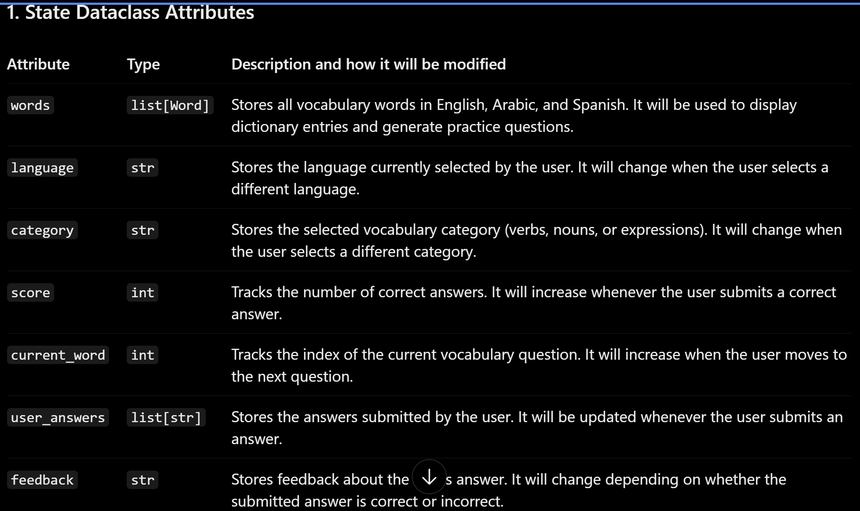
Second Dataclass  Your second dataclass, including its attributes, their types, and how they will be meaningfully modified (if they are modified) | 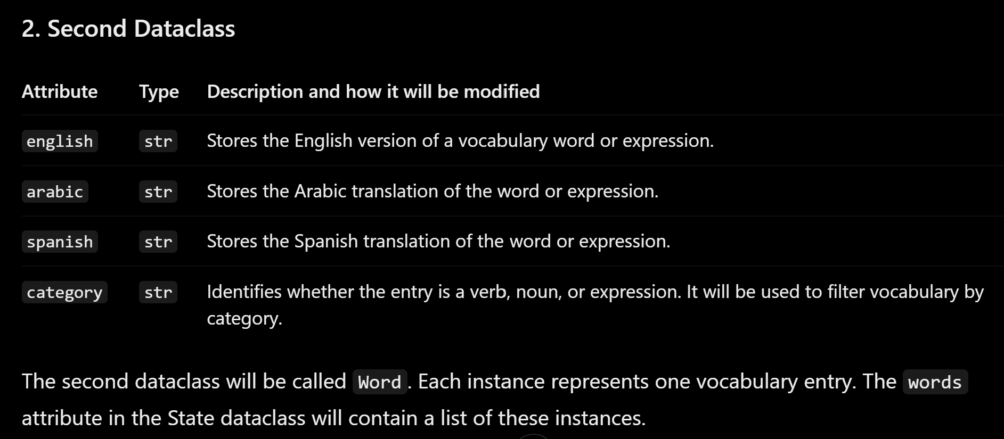
Routes (minimum 7)  The names of your route functions | 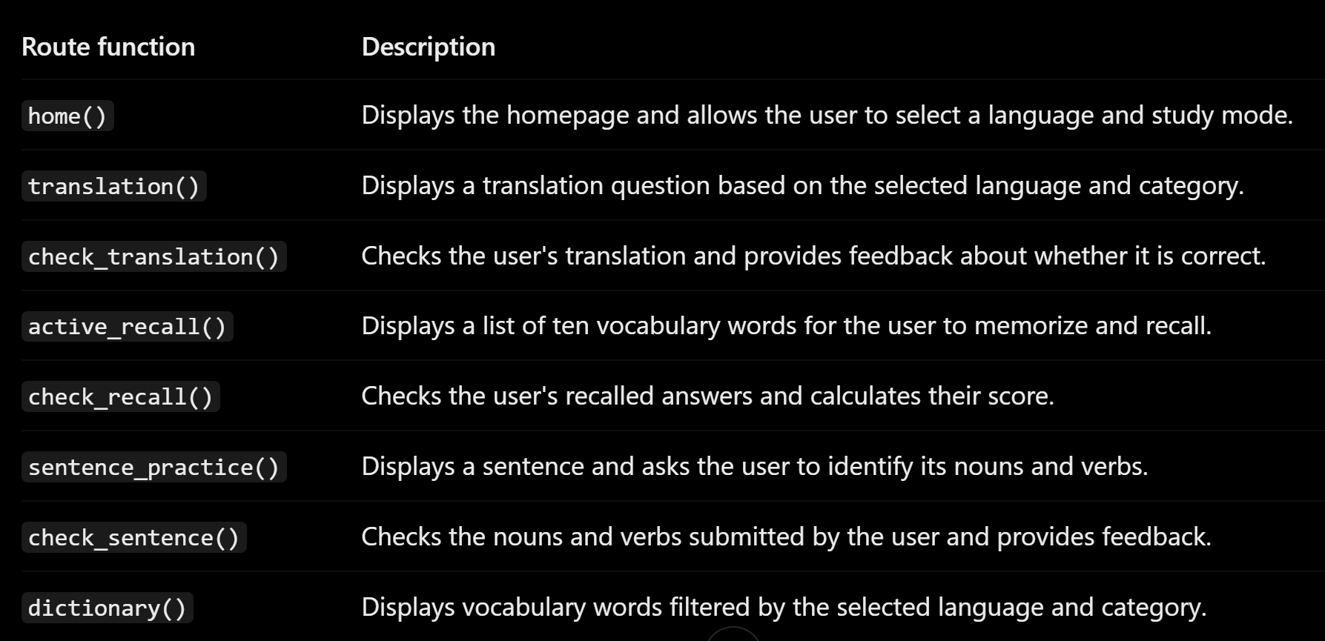
Pages (minimum 5)  A brief description of the pages in your site | 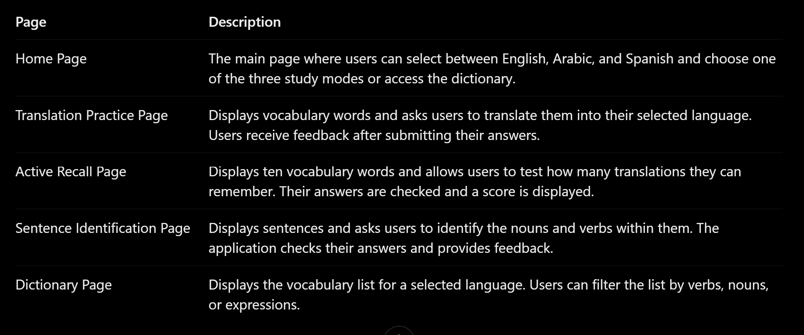
User Input (minimum 3)  Description of user input components (TextBox, TextArea, CheckBox, or SelectBox) and their purposes  For more information on these input types, see Drafter Documentation. | 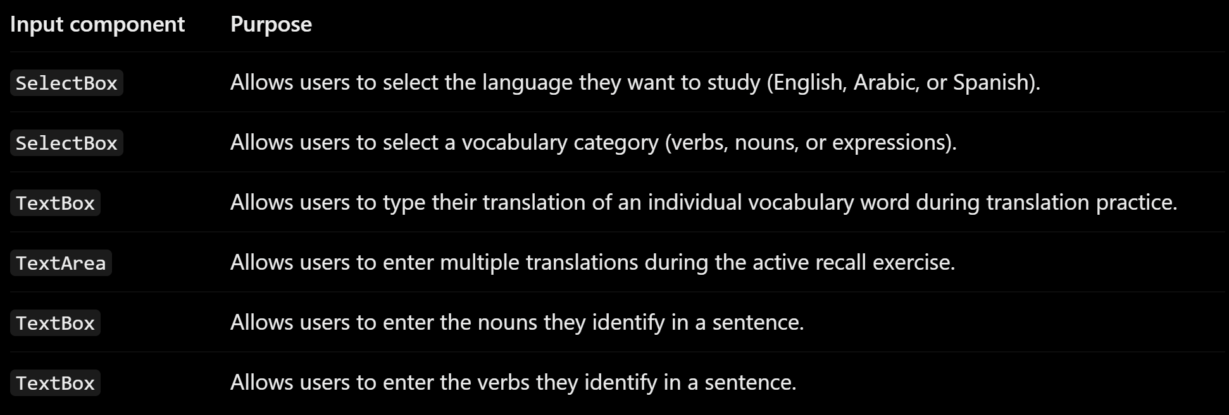
If Statements (minimum 3)  Brief description of what will be evaluated in your if statements and how they will meaningfully change the logic of the site | 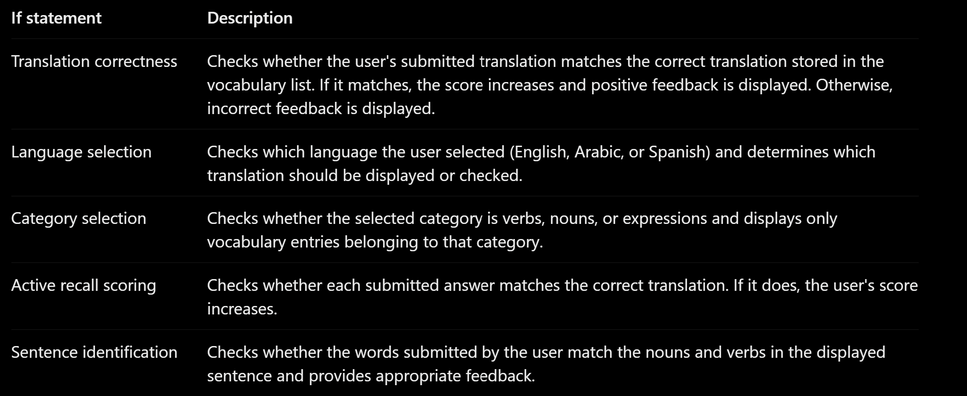
Loop (minimum 1)  This loop must iterate over the list/dict of dataclass instances in your State attribute.  Description of this loop and why it is meaningful to the site | 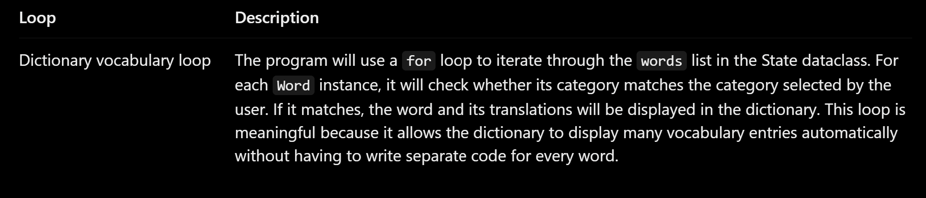

LLM Conversation
If you used an LLM in any part of this work, copy and paste every part of that conversation below. Otherwise, you may be given a zero for the assignment. Obviously, these words will not all be yours, and this is the exception to the requirement at the top of this assignment that all responses be in your own words. If you did not use an LLM to assist you in this assignment, simply say so below.
This is my idea for the website project that I am going to work on: I want to build a website that helps me review the most used verbs (100 verbs), nouns (100 nouns), and expressions (20 expressions) in each of the languages that I know (Arabic, English, Spanish). want this web application to be used as a review tool for languages (in my case, English, Arabic, and Spanish). This program will assist in retaining user’s knowledge about a specific language through textual input. Inputs that the program will receive include: Answers to the questions being asked by the program (These questions vary depending on the mode of study that the user chooses). There are (most likely) three modes of study… translating between languages (nouns, verbs, and expressions), active recall flash cards (how many can you remember from a list of ten verbs/nouns), and identifying verbs and nouns in sentences. There will also be a list of words that acts as a dictionary. The program will process it by doing: Compare the input against a database and give feedback to the user. The output of the program will be: A checkmark representing correctness. A list of words when clicking the button linked to the dictionary of a specific language. And a number representing how many words you correctly remembered from the “active recall” list. (this last one might be replaced by the “chat with the machine” feature explained later in this document.) I want to include this feature: I might use gemini’s API to allow for real time conversation between my website (AI under the hood) and the visitor . Alright.....Based on all of the above, can you do this: Create a mock-up of your planned website. keep it simple. Your goal should be to make a very quick and dirty diagram, to show that you have some kind of idea of my program.

I recommend drawing each page as a rectangle, and laying out the text, buttons, and other components inside. Then, use arrows to indicate links between pages. Label each page the way you will name each function, and then put labels on the arrows to indicate what the button links. Also write down any parameters that should come into the pages.

In addition to the pages and routes, write down what fields the `State` will have, both their names and types. Try to keep it simple and not have too many pages. Also, make sure that the website fullfills these requirements:
- At least 7 routes.
- At least 5 pages.
- The implementation of the State dataclass must have at least 4 fields.
  - At least one field must be a list of class instances or a dictionary of class instances.
    - This means that there must be a second dataclass.
  - At least 4 state fields, including the list or dictionary of class instances, must each be meaningfully modified in at least one route; those 4 state fields cannot be constants.
- At least 3 input fields (TextBox, CheckBox, SelectBox, TextArea). They don't have to be the same type.
- At least 3 meaningful if statements.
- At least 1 loop that iterates over an attribute of the list of class instances or dictionary of class instances in a meaningful way.
- No global variables ( are fine).
- You must use the Drafter library.
…
Your idea is very suitable for a Drafter project! I recommend keeping the application relatively simple and organizing it around one main dashboard and three study modes, with a dictionary page.
I would also recommend postponing the Gemini AI conversation feature until the basic application works. Connecting an external API from Pyodide can be challenging because of browser security restrictions (CORS), API keys, and network limitations. You can still build a very useful language-learning application without it.

1. Website mock-up
Let's call the application Polyglot.
I recommend using 5 main pages and 8 routes. Some routes will reuse the same page but accept different parameters.

Page 1: Home page — home()

Polyglot
Language learning

Welcome to Polyglot!
Review your vocabulary and improve your language skills.
Choose a language:

English

العربية

Español
Study modes
1. Translation practice
Translate words and expressions.
Start translating
2. Active recall
Remember as many words as possible.
Start recalling
3. Sentence identification
Identify verbs and nouns in sentences.
Start identifying
Other
Dictionary

Page 2: Translation page — translation(language, category)
The user chooses a language and a category (verbs, nouns, or expressions).

Translation Practice
Language: Spanish | Category: Verbs
Translate this word into Spanish:

To eat
Your answer
Type your translation...
✓ Correct!
Question 1 of 10
Check answer
Next word
Correct answer: Comer
Possible categories:
- Verbs (100 words)
- Nouns (100 words)
- Expressions (20 expressions)
The application compares the user's answer with the correct translation.

Page 3: Active recall page — active_recall(language, category)
The user receives a list of ten words and tries to remember their translations.

Active Recall
Language: Arabic | Category: Nouns
Remember the translations of these words!
- House
- Book
- Water
- School
- Friend
- Food
- City
- Door
- Family
- Work
- How many did you remember?
- Enter your remembered words...
- Check answers
- Your score: 7 / 10
For simplicity, I recommend letting users type their answers into a text area, then comparing them against the correct translations.

Page 4: Sentence identification — sentence_practice(language)
The program presents a sentence, and the user identifies the nouns and verbs.

Identify the Words
Language: English
Identify the nouns and verbs in this sentence:
The boy eats an apple.
Nouns
Enter nouns...
Verbs
Enter verbs...
Check answers
Correct!
Nouns: boy, apple | Verb: eats

Page 5: Dictionary — dictionary(language, category)
This page displays the vocabulary available for each language.

Dictionary
Select a language
Spanish
Select a category
VerbsNounsExpressions
English | Spanish
To eat | Comer
To drink | Beber
To speak | Hablar
To read | Leer
To write | Escribir
Example vocabulary only

2. Routes and navigation
I recommend the following routes. This gives you 8 routes while keeping the number of actual page designs small.
Route | Function | Parameters
1 | home() | None
2 | translation() | language, category
3 | check_translation() | User's answer
4 | active_recall() | language, category
5 | check_recall() | User's answers
6 | sentence_practice() | language
7 | check_sentence() | Nouns and verbs entered
8 | dictionary() | language, category

Navigation diagram
HOME — home()
Select language and study mode
Translation
translation()
Check answer
check_translation()
Active recall
active_recall()
Check answers
check_recall()
Sentence practice
sentence_practice()
Check sentence
check_sentence()
Dictionary
dictionary()
Display word list
Same dictionary page
Navigation buttons on each page return to home()
The check_translation(), check_recall(), and check_sentence() functions can return the same page with feedback rather than creating entirely new pages.

3. State dataclasses
This is an important part of your project because your assignment requires at least two dataclasses and four meaningfully modified State fields.
I recommend two dataclasses:
Dataclass 1: Word
Represents one vocabulary entry.
Field | Type | Example
english | str | "To eat"
arabic | str | "يأكل"
spanish | str | "Comer"
category | str | "verb"
Dataclass 2: State
Represents the current application state.
Field | Type | Purpose
words | list[Word] | Stores all vocabulary entries
language | str | Current language
category | str | Current category
score | int | Number of correct answers
current_word | int | Index of current question
user_answers | list[str] | Stores the user's answers
feedback | str | Displays correctness feedback
This gives you seven fields, and you can meaningfully modify more than the required four.
For example:
- words: You can add or remove vocabulary entries.
- language: Changes when the user selects another language.
- category: Changes when the user selects verbs, nouns, or expressions.
- score: Increases when the user answers correctly.
- current_word: Increases when the user moves to the next question.
- user_answers: Updates when the user submits an answer.
- feedback: Changes depending on whether the answer is correct.

4. How your project satisfies the assignment requirements
Requirement | Your implementation
At least 7 routes | 8 routes
At least 5 pages | 5 page designs
At least 4 State fields | 7 fields
Second dataclass | Word
List of class instances | words: list[Word]
4 modified State fields | language, category, score, user_answers, etc.
At least 3 input fields | TextBox, TextArea, SelectBox
At least 3 meaningful if statements | Answer checking, language selection, category selection
At least 1 meaningful loop | Iterate through words to display dictionary entries
No global variables | Keep application data in State
Drafter library | Build all pages and routes using Drafter

5. Examples of required programming concepts
Here are some examples of where the required programming concepts naturally fit.
If statements
- Check whether the user's translation is correct.
- Check whether the selected category is verbs, nouns, or expressions.
- Check whether the user selected Arabic, English, or Spanish.
- Check whether the user has remembered all ten words.
Loops
Your dictionary page can iterate through the words list:
for word in state.words:
if word.category == state.category:
# Display the word
Inputs
You can use:
- TextBox for translation answers.
- TextArea for active recall answers.
- SelectBox for choosing languages and categories.

6. My recommendations for keeping the project manageable
Recommended scope
I would divide development into three stages.
Stage 1 — Build the foundation
- Create the five pages.
- Implement navigation between pages.
- Create the Word and State dataclasses.
- Add a small vocabulary list initially (perhaps 10 words per language).
Stage 2 — Implement the study modes
- Translation practice.
- Active recall.
- Sentence identification.
- Dictionary filtering.
Stage 3 — Improve the application
- Add the remaining vocabulary (100 verbs, 100 nouns, and 20 expressions per language).
- Improve the visual design.
- Consider saving progress using browser local storage.
One important technical recommendation: Since Drafter runs in the browser using Pyodide and has no backend database, you can store your vocabulary directly in your Python program as a list of Word objects. You do not need an external database. You can also use local storage to preserve progress between visits.
I would leave the Gemini conversation feature as an optional extension. It is a much more complicated feature than the other three study modes.
My suggested next step: Start by implementing the Word and State dataclasses and the home page. Once those work, the other pages will be much easier to build.
Here are some questions that the planning work sheet asked, can you answer them for me and make a table and put the answers in it corresponding to each question in the same order you see below so I can easily copy it:
State Dataclass Attributes

Minimum of 4 attributes, one of which must be a list/dict of instances of your second dataclass.

Briefly describe each attribute, its type, and how it will be meaningfully modified throughout the site.
Second Dataclass

Your second dataclass, including its attributes, their types, and how they will be meaningfully modified (if they are modified)
Routes (minimum 7)

The names of your route functions
Pages (minimum 5)

A brief description of the pages in your site
User Input (minimum 3)

Description of user input components (TextBox, TextArea, CheckBox, or SelectBox) and their purposes

For more information on these input types, see .
If Statements (minimum 3)
Brief description of what will be evaluated in your if statements and how they will meaningfully change the logic of the site
Loop (minimum 1)
This loop must iterate over the list/dict of dataclass instances in your State attribute.
Description of this loop and why it is meaningful to the site
…
Below is a completed table based on your Polyglot language-learning website idea. I've kept the answers relatively simple, specific, and appropriate for a CS1 introductory programming project. You should be able to copy each answer directly into your worksheet.

1. State Dataclass Attributes
Attribute | Type | Description and how it will be modified
words | list[Word] | Stores all vocabulary words in English, Arabic, and Spanish. It will be used to display dictionary entries and generate practice questions.
language | str | Stores the language currently selected by the user. It will change when the user selects a different language.
category | str | Stores the selected vocabulary category (verbs, nouns, or expressions). It will change when the user selects a different category.
score | int | Tracks the number of correct answers. It will increase whenever the user submits a correct answer.
current_word | int | Tracks the index of the current vocabulary question. It will increase when the user moves to the next question.
user_answers | list[str] | Stores the answers submitted by the user. It will be updated whenever the user submits an answer.
feedback | str | Stores feedback about the user's answer. It will change depending on whether the submitted answer is correct or incorrect.

2. Second Dataclass
Attribute | Type | Description and how it will be modified
english | str | Stores the English version of a vocabulary word or expression.
arabic | str | Stores the Arabic translation of the word or expression.
spanish | str | Stores the Spanish translation of the word or expression.
category | str | Identifies whether the entry is a verb, noun, or expression. It will be used to filter vocabulary by category.
The second dataclass will be called Word. Each instance represents one vocabulary entry. The words attribute in the State dataclass will contain a list of these instances.

3. Routes (minimum 7)
Route function | Description
home() | Displays the homepage and allows the user to select a language and study mode.
translation() | Displays a translation question based on the selected language and category.
check_translation() | Checks the user's translation and provides feedback about whether it is correct.
active_recall() | Displays a list of ten vocabulary words for the user to memorize and recall.
check_recall() | Checks the user's recalled answers and calculates their score.
sentence_practice() | Displays a sentence and asks the user to identify its nouns and verbs.
check_sentence() | Checks the nouns and verbs submitted by the user and provides feedback.
dictionary() | Displays vocabulary words filtered by the selected language and category.

4. Pages (minimum 5)
Page | Description
Home Page | The main page where users can select between English, Arabic, and Spanish and choose one of the three study modes or access the dictionary.
Translation Practice Page | Displays vocabulary words and asks users to translate them into their selected language. Users receive feedback after submitting their answers.
Active Recall Page | Displays ten vocabulary words and allows users to test how many translations they can remember. Their answers are checked and a score is displayed.
Sentence Identification Page | Displays sentences and asks users to identify the nouns and verbs within them. The application checks their answers and provides feedback.
Dictionary Page | Displays the vocabulary list for a selected language. Users can filter the list by verbs, nouns, or expressions.

5. User Input (minimum 3)
Input component | Purpose
SelectBox | Allows users to select the language they want to study (English, Arabic, or Spanish).
SelectBox | Allows users to select a vocabulary category (verbs, nouns, or expressions).
TextBox | Allows users to type their translation of an individual vocabulary word during translation practice.
TextArea | Allows users to enter multiple translations during the active recall exercise.
TextBox | Allows users to enter the nouns they identify in a sentence.
TextBox | Allows users to enter the verbs they identify in a sentence.

6. If Statements (minimum 3)
If statement | Description
Translation correctness | Checks whether the user's submitted translation matches the correct translation stored in the vocabulary list. If it matches, the score increases and positive feedback is displayed. Otherwise, incorrect feedback is displayed.
Language selection | Checks which language the user selected (English, Arabic, or Spanish) and determines which translation should be displayed or checked.
Category selection | Checks whether the selected category is verbs, nouns, or expressions and displays only vocabulary entries belonging to that category.
Active recall scoring | Checks whether each submitted answer matches the correct translation. If it does, the user's score increases.
Sentence identification | Checks whether the words submitted by the user match the nouns and verbs in the displayed sentence and provides appropriate feedback.

7. Loop (minimum 1)
Loop | Description
Dictionary vocabulary loop | The program will use a for loop to iterate through the words list in the State dataclass. For each Word instance, it will check whether its category matches the category selected by the user. If it matches, the word and its translations will be displayed in the dictionary. This loop is meaningful because it allows the dictionary to display many vocabulary entries automatically without having to write separate code for every word.
One important note for your implementation: Your State dataclass should be initialized with a list of Word instances. The words list should contain the vocabulary data, rather than having separate lists for English, Arabic, and Spanish. This makes your second dataclass requirement straightforward to demonstrate.
Also, your routes can share page designs: for example, check_translation() can return the translation practice page with updated feedback. You do not need eight completely different pages to satisfy the eight-route requirement.

Final Submission
When you are finished, download this file as a Word Document (docx) and upload the file to the appropriate assignment on Canvas.

